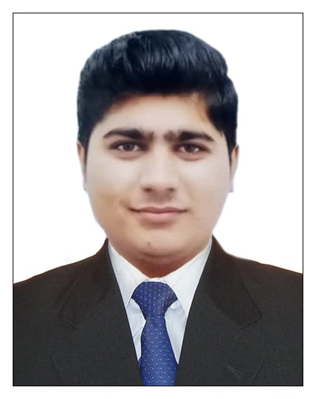
CURRICULUM VITAE

DHRUMILPANCHAL
Mob:0528930411(UAE)
Mob:+91-9974742059(IND)
Emaild:dhrumilp369@gmail.com

Application forAnySuitablepost

Objectives

Lookingfortheopportunityto workwithyourprogressiveorganizationthat givesmescopetoupdatemyknowledgeandskillsinaccordancewiththeattest trends andbea partofthemthatdynamicallyworkstowardsthegrowthoforganizationand gain satisfactionthereof.Suitable

Personalskills

• Computerbasic knowledge
• asp.net & macro media flash professional
• Office coordination office assistance

PersonalInformation

Name
Father’sName
DateOfBirth Nationality Gender MaritalStatus
:: DHRUMIL PANCHAL
:: JYOTINDRA
:: 30/05/1996
:: Indian
:: Male
:: Unmarried

AcademicEducation

Academic Computer Professional

Languages:
:: B.C.A.completed
:: coding with asp.net & basic
:: British IELTS

Gujarati,EnglishandHindi
ExperienceSummary:

  - First worked from-may2018HDFCTwo-wheelerloginmaster till-2019january
  - another workedwithomsaimobilecenterasasalesboy fromfeb-2019to nov-2019.
  - And also workedwithjaliwalaperforatedindustriesasamanagerfromfeb-2020to may-2020.
  - worked with U&VVENTURE'S IN TVS Two-wheeler showroom from july2020-feb 2021.
  - last working with Al Adil supermarket (multispice foodstuff llc)in UAE (DUBAI) As a computer operator + cashier from may 2021-jun 2023.

PassportDetails

• PassportNo
• Dateofissue
• DateofExpiry

Declaration
:: T0368849
:: 06/12/2018
:: 05/12/2028

HereI amkindlydeclaredthattheabovementioneddetailsall aretruein thebestofmy knowledgeandbelieve.

